 In Memory of Webb “Tony” Smith
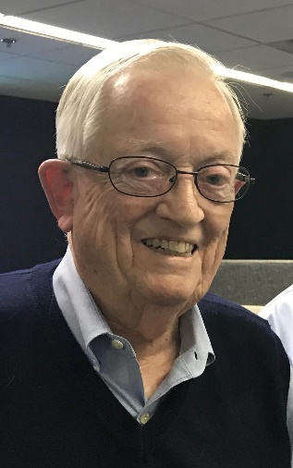
Webb Anthony (Tony) Smith died on April 2, 2025, in New Smyrna Beach, Florida, his winter home, following several hospitalizations with pneumonia and complications thereof. Tony was born to Jack and Helen Smith on Friday, September 9, 1938, in Lansing Michigan. He was born to become a Spartan. As a young boy, he saved his allowance, and when in kindergarten he purchased his first Spartan Football game ticket. He was immediately hooked on the “Green and White”. At age twelve he saved his paperboy earnings for a year to buy his first season ticket for $12. He proudly held Spartan season tickets for over 70 years.
Tony attended Sexton High School and excelled academically and in sports. Notwithstanding his rather small stature, he was a varsity basketball player and a track and field/cross country star. He ran the mile in a Sexton High School record time of four minutes and thirty seconds. As he was destined to do, Tony then spent four blissful years at Michigan State University--a place with which he has had a lifelong love affair. While there he served in the ROTC and earned a degree in Social Science with Honors. He was a four-year varsity runner on the Spartan Track and Cross Country Teams. They won three MSU Big Ten Championships, three Intercollegiate 4A Championships, and two NCAA National Championships. The camaraderie of his teammates was treasured throughout his life.
After graduating from MSU, Tony traveled down the road to that “other” school to earn his law degree at the highly esteemed University of Michigan Law School. In a 2004 newspaper interview, Tony described his affinity for that institution as follows: “The single greatest highlight of those three miserable years in Ann Arbor was the day I graduated and moved back to East Lansing”. In 1962, while still in Law School, Tony interviewed with what was then known as Foster, Campbell, Lindemer & McGurrin. Larry Lindemer and John Collins hired him as the firm’s very first summer associate and he joined the firm as a full time associate in December of 1963. Tony hit the ground running, and within the first three months as a new lawyer at the firm, he enjoyed success in his first two jury trials.
Uncle Sam called. He took a leave of absence from the firm to repay his debt to the ROTC by serving his country in the United States Army. While at Camp Pickett Virginia, Lt. Webb Smith was able to accomplish what he characterized as his “greatest lifetime achievement” --finding Patricia and convincing her to marry him and come to Michigan. They raised three wonderful children and have treasured any time with grandchildren.
During his six decades of lawyering at the firm that would come to bear his name--Foster, Swift, Collins & Smith--Tony handled any type of litigated matter, spanning from a corporate espionage case that culminated in a murder suicide, representing dairy farmers in the PBB case, the ground breaking “right to strike” litigation for the early Michigan Education Association, to the Pigeon River Case for Shell Oil Company.
Over his career Tony earned enumerable honors and accolades, including: Being elected Ingham County Bar President; earning the Leo Farhat Outstanding Attorney Award; being awarded the Excellence in Defense Award; winning the title of Top Commercial Litigator (2006); being elected by his peers as a Fellow of the prestigious American College of Trial Lawyers; winning the Thomas Brennan Lifetime Achievement Award; being awarded the Outstanding Achievement Award by the Negligence Law Section of the State Bar of Michigan; and earning annual recognition in the Best Lawyers in America, and Super Lawyers since their inception. While his achievements may be impressive, they constitute only a small part of the myriad of reasons he will be missed. He was an incredibly honest, loyal, and accepting man of integrity. Throughout his professional and personal life, Tony has always been kind and humble. While he had exacting standards for himself: He came to his marriage with his childhood Monopoly set without a single piece missing and he never missed work. Even so, he was loving, patient and tolerant of others who struggled or did things differently.
Tony loved sports--especially when his Spartans were playing. The “Fight Song” and MSU Shadows were his favorite songs. He was an original “foodie” who preferred unique local spots for a burger or specialty of the house. When traveling, he would always choose a small village or town rather than a big city. Even if he could not speak the language, he could communicate with anyone anywhere and find common ground. He loved being able to introduce his children and grandchildren to different places and cultures. His generosity and hospitality were legendary as he was always ready to open his doors to family and friends to celebrate life. Local theater was a favorite activity, especially attending any play at Peppermint Creek. As a longtime member of St. Paul’s Episcopal Church, he held many leadership roles.
Webb was predeceased by his son, Webb Smith Jr. He is survived by his wife of almost 60 years, Patricia; his daughter Betsy Smith and Barbara (Graham) Merwin; grandchildren; Reagan, Jack and Sarah Mishler; Aubrie Smith and Leslie (McLain) Moberg and their mother Lori; and Joseph (Mandi) Shepherd and Eric (Sara) and DJ Wood. He was Gpa or Papa to six wonderful great grandchildren: Blaire Moberg, Hanna and Alayna Shepherd, Jared Pennington, and Leo and Lily Wood.
Memorials may be made to MSU Cross Country, Ingham County Bar Association Foundation, Peppermint Creek Theater, St. Paul’s Episcopal Church or to a charity of your choice.
He was cared for by the Settle-Wilder Funeral Home in New Smyrna Beach, Florida.
A Celebration of Life for Webb will be held later in Michigan.

